**Cookbook to convert Word to HTML (Reports)**

|  |  |  |  |
| --- | --- | --- | --- |
| **Date** | **Version** | **Author** | **Description** |
| 10-Dec-2021 | V1 | Lydia | Initial Doc to HTML |
| 21-Dec-2021 | V2 | Lydia | Changes made in the procedure that was followed to convert Doc to HTML |

**Prerequisites:**

* *Before initiating the workflow below, please ensure that the Signoff from ISV is obtained for the report you intend to publish. This is required to avoid non-compliance, because the workflow utilizes third part urls to convert the Doc to HTML format.*
* *Create a HTML Template for Reports with 3 columns**(Index | Content | Table of Contents) PFB the Format.   
    
  (Make a copy of that for the new Report Template and open it in a text editor and keep it ready.)*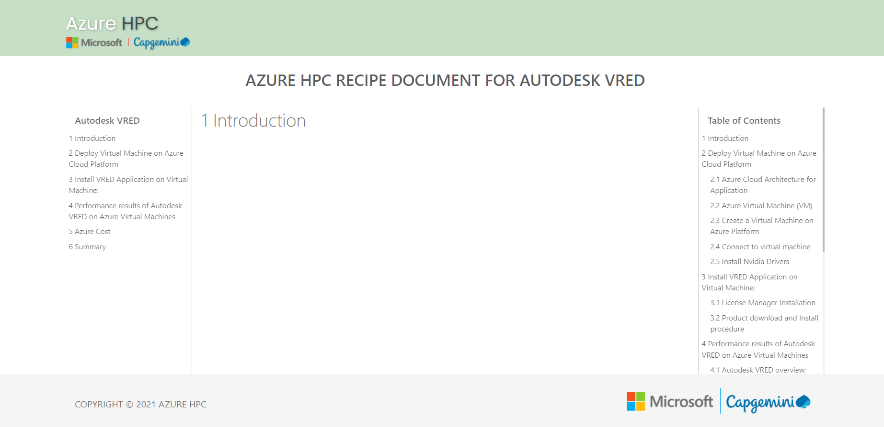

**STEP 1:** Switch Off any type of VPN that is connected.

**STEP 2:** Open the url: <https://www.aconvert.com/document/doc-to-html/>

**STEP 3:** Choose the original report which is in Doc format and click ‘**Convert Now!’**  
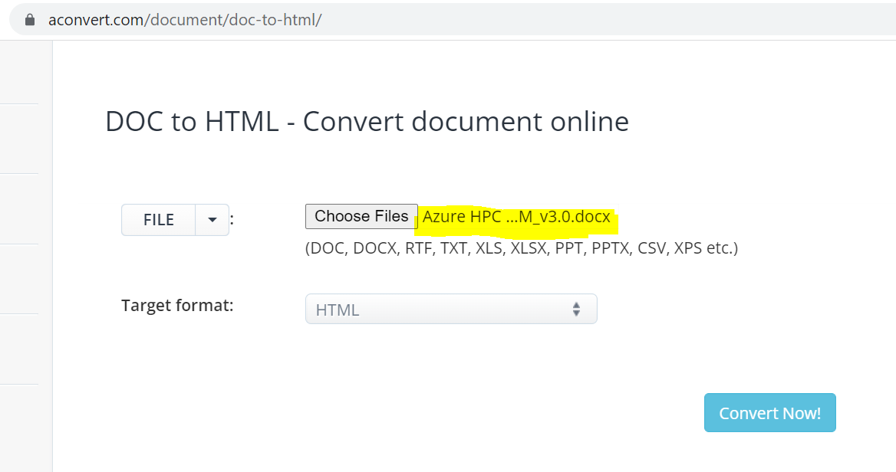

**STEP 4:** Click on ‘**Add to Zip’** and then on **the url link** created to save the converted files in a folder format.

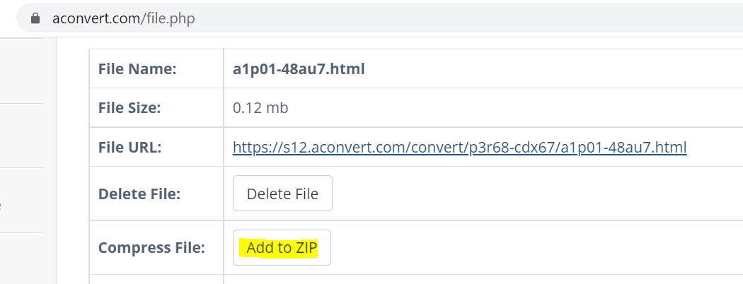  
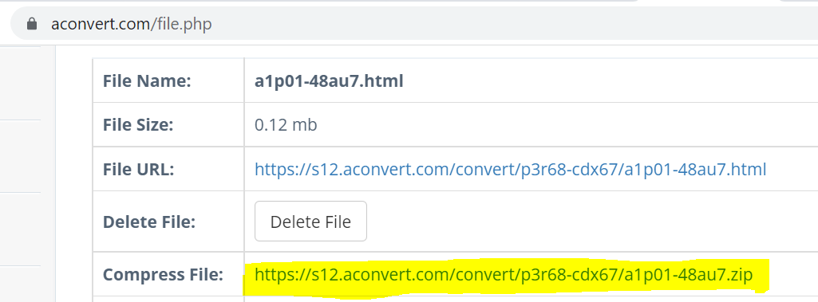  


**STEP 5:** Extract the Zip folder [Zip folder has all the images + the html + doc file]  
**STEP 6:** Copy all the images separately into a new folder.  
**STEP 7:** Delete some of the unwanted files from the images folder.  
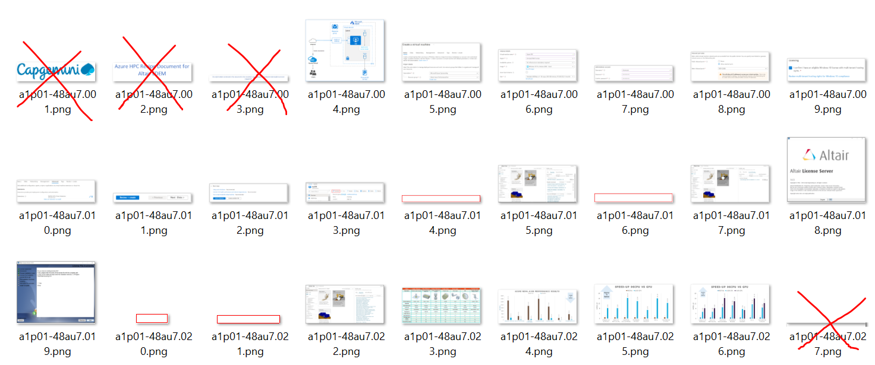

**STEP 8:** Copy the Images Folder and add it into the Project Folder. Also rename it according to the <Report Name>_Files (eg. nanoFluidX_files).  
**STEP 9:** Open the downloaded HTML file in a text editor. Copy the code and paste it on the  HTML Tab in the below mentioned URL: <https://wordhtml.com/>. [This is to clean up the html code for extra spaces, so that it will make the code more readable.]

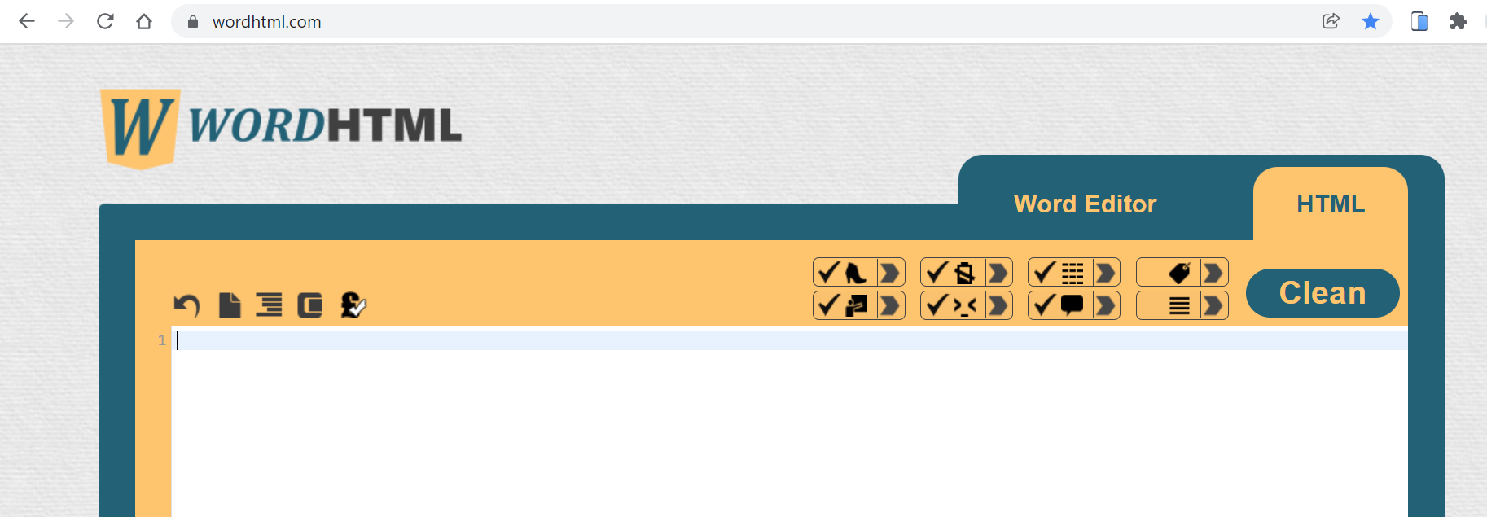

**BEFORE:**  
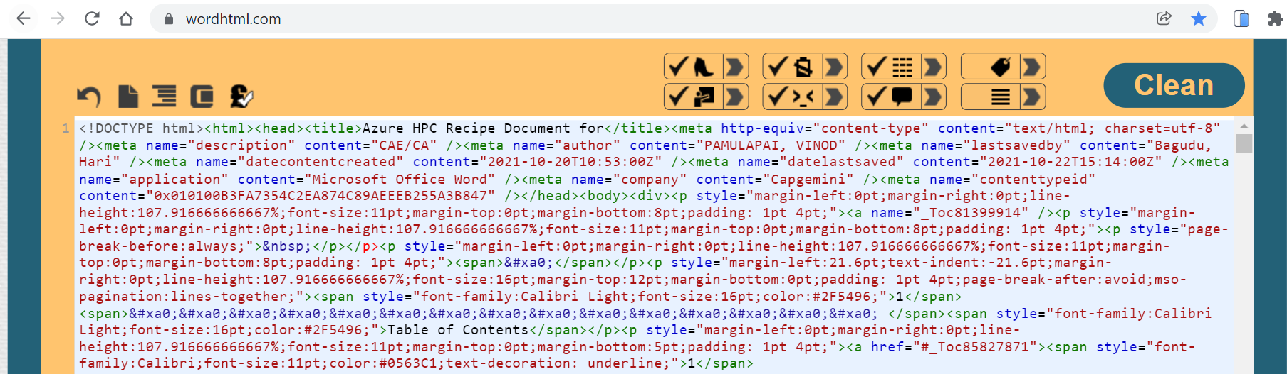

**a. Delete tags with one space**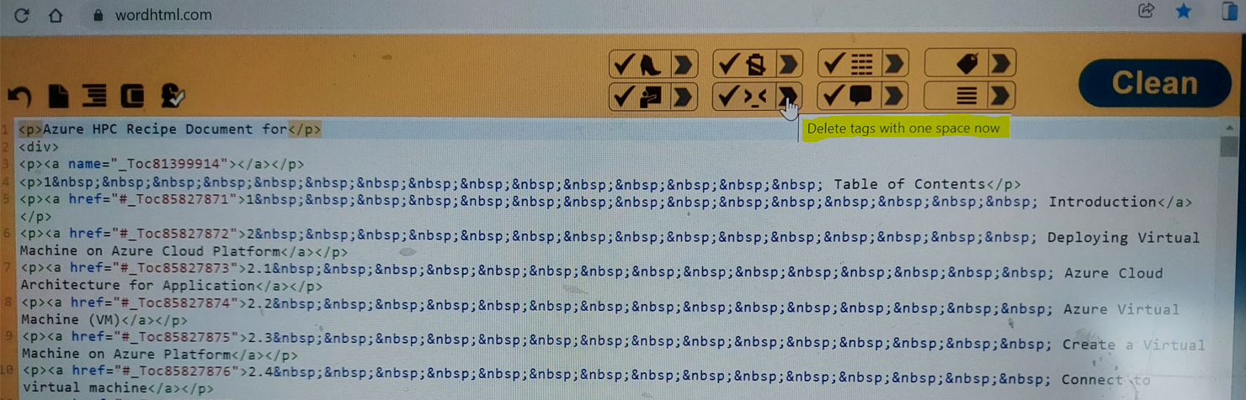  
**b. Delete successive spaces**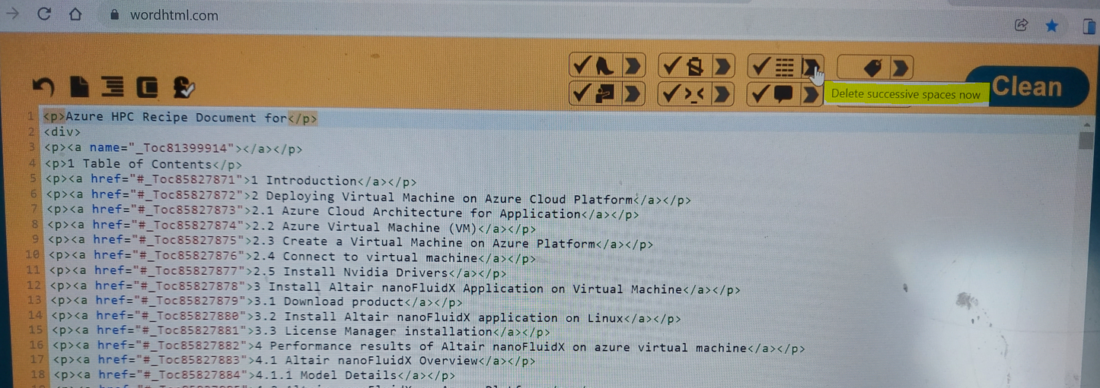

**c. Copy the Table of contents and paste in in the toc section of the new Report Template under <label class="px-3">Table of Contents</label> in the template**.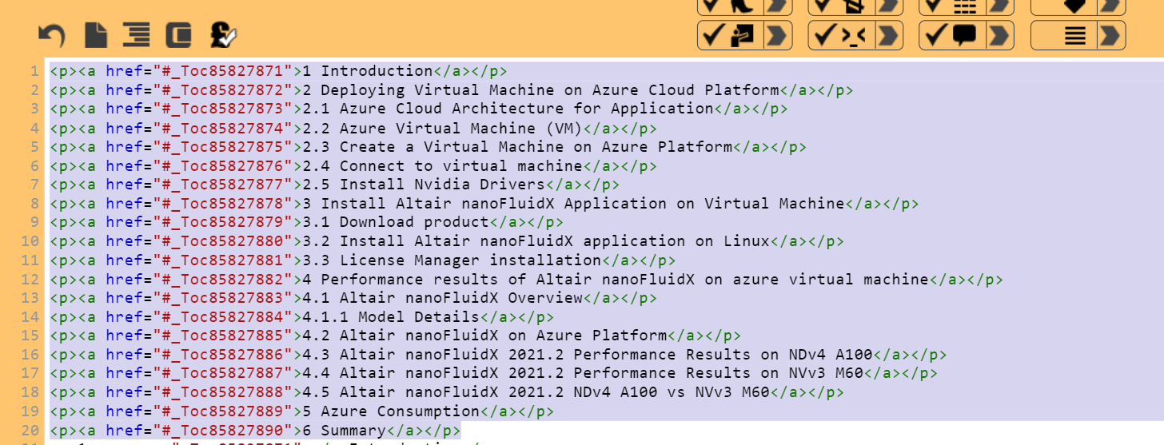

**d. Add the same under <div class="index-scroll"> as well (but Remove the Sub-Heading (2.1 – 2.4) from the <div class="index-scroll"> section.)  
Remove all the 2.1 to 4.5 sub Table of contents**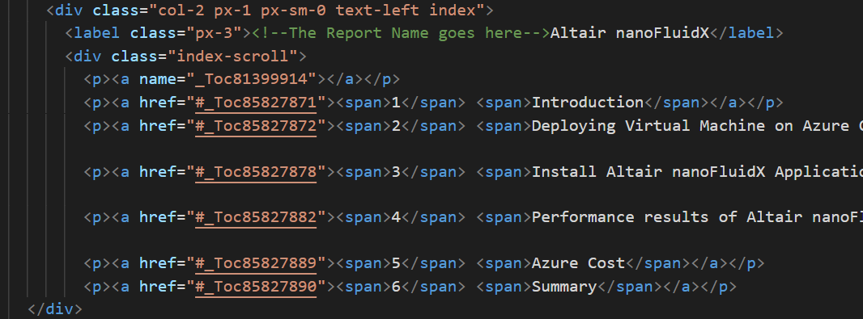

**STEP10:** Copy rest of the html code and paste it into the Report Template in the **content section** that is created under **<!--The Report content goes here-->  
  
a.** Change the **Report Name** in the Header & in the Index Section  
**b. Add <div class="overflow-table">** before every <table> within the content.  
**before: after:**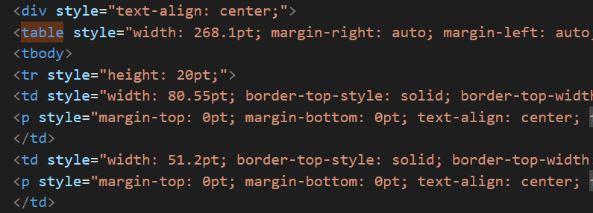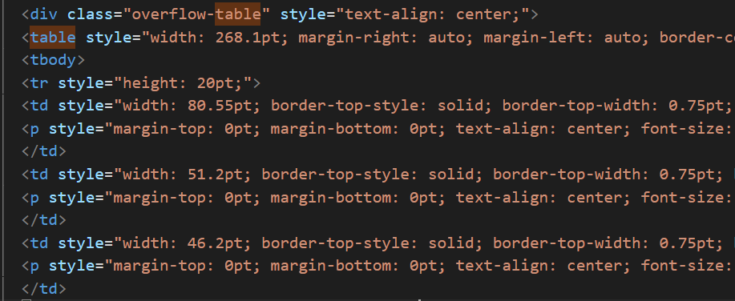

**c. Add a space between <1Introduction> from 1to 6** in both **Index section** & in **toc section  
before: after:**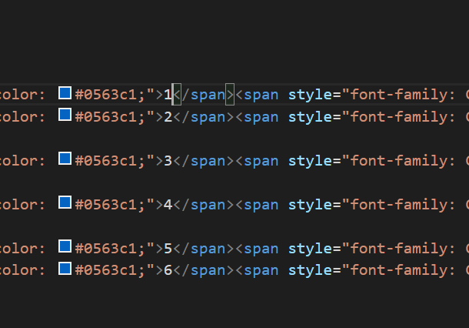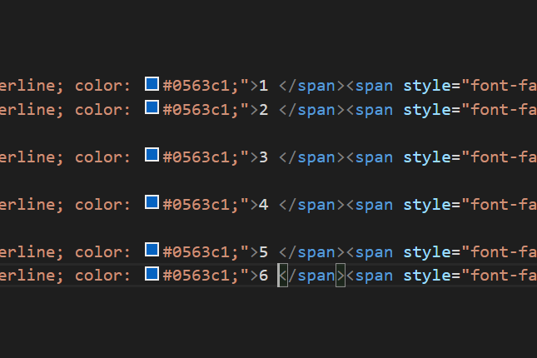

**STEP11:** Add the Images Folder within the Project Folder after renaming it as per the Report Name. Rename the <img src=”file name”> as per the images folder name.  
**before: after:**  
 